Tableau Project 2

As I reviewed the data sheet that was given, I decided to create a format that was based on sales dates (by years) and the profit (for each department sections). The data was based on the southern regions of the profit from 2014- 2018. The profit map that I created within the format focused on the states and its profits. In my project, I focused on the high performing state, which was Florida. With that being said, throughout the project my main topic was Florida and its profit sales dates by year. Additionally, in the project, I wanted the viewers to see the changes throughout the data, so I focused on one department within the State of Florida and that was lotions. The lotions department was one of the lowest receiving departments in Florida. This information was chosen because many of the columns and rows that I chose focused on the positive profit of each state and the changes that happened throughout the year 2014 - 2018. Nevertheless, I wanted to be able to show the viewers the changes within the regions. Then create positive profit bar chart to show the lowest profit receiving location of Florida. So, I built a storyline to include all this information and Florida’s data profits. In this project, I created four different designs with one map to give viewers a better understanding of the region, sales dates, and profit in each department.

**Workbook Sheet 1** 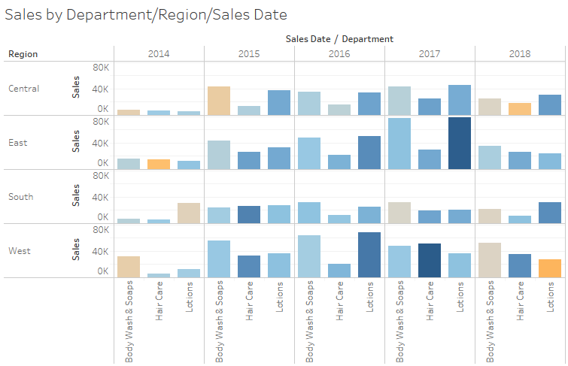

In this worksheet I created a format that showed all the regions and the sales dates within all the departments by the year. This visualization was important because it showed the overall sales dates and each department tin the region. The data chose for this visualization displays all the regions. Additionally, the visualization displayed the sales by department. In this format the viewers could see the department sales all at once. In my opinion this visualization format is meaningful because it showed all the important data that has been used throughout the project.

**Workbook Sheet 2**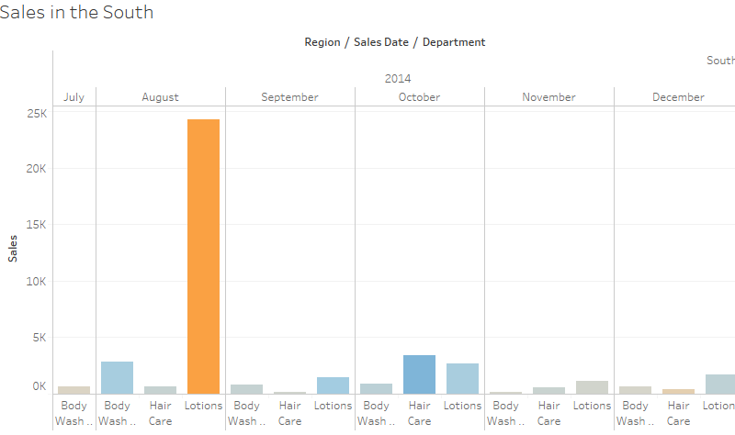

In this worksheet I created a format that showed all the southern regions and the sales dates within all the departments by the year. This visualization was important because it showed the sales dates (by month and year) and each department. The data chose for this visualization displays all the southern regions. Additionally, the visualization displayed the sales by department. In this format the viewers could see the department sales in the south all at once. In my opinion this visualization format is meaningful because it showed all the important data that has been used throughout the project.

**Workbook Sheet 3**

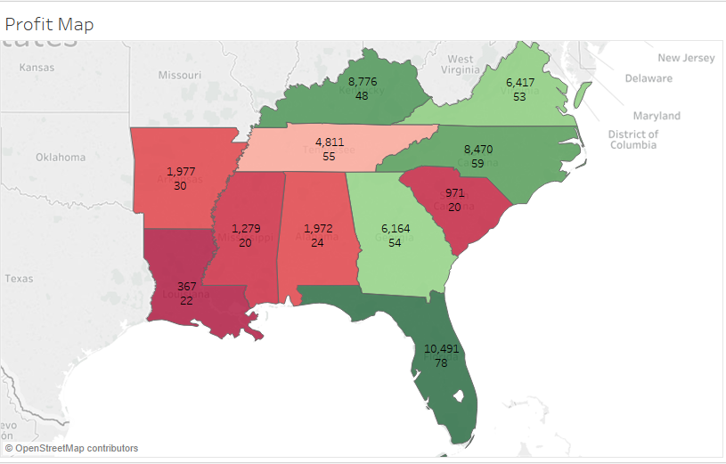

In this worksheet I created a format that showed all the southern regions and the profit. This visualization was important because it showed the profits in each state. The data chose for this visualization displays all the southern regions. Additionally, the visualization displayed the profit rate of the department in each state. In this format the viewers could see the profit sales in the south all at once. In my opinion this visualization format is meaningful because it showed all the important data that has been used throughout the project.

**Workbook Sheet 4** 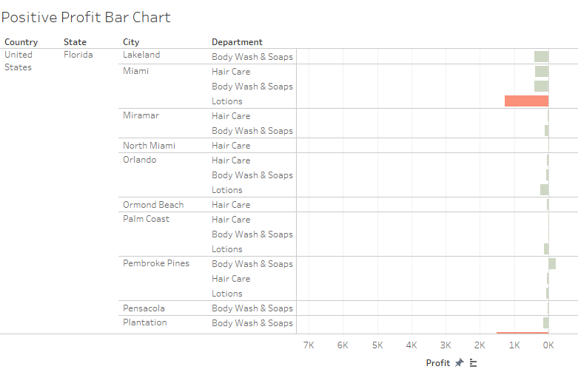

In this worksheet I created a format that showed all the southern regions and the profit. This visualization was important because it showed the profits in each city. The data chose for this visualization displays all the southern regions. Additionally, the visualization displayed the profit rate of the department in each state and city. In this format the viewers could see all the profit sales in the south regions all at once. In my opinion this visualization format is meaningful because it showed all the important data of the department profits.

**Workbook Dashboard** 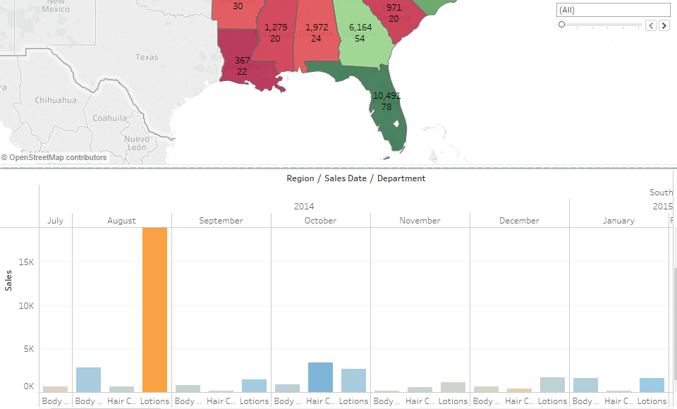

In this worksheet I created a format that showed all the southern regions and the profit. The importance of this collection of visualization was to show the sales dates (by month and year). The data chose for this visualization displays all the southern regions. Additionally, the visualization displayed the profit rate of the department in each state. In this format the viewers could see the profit sales in the south all at once. In my opinion this visualization format is meaningful because it showed all the important data that has been used throughout the project.

The overall process of this narrative was to show the departments profit and sales rates throughout the profit. The first worksheet showed all of the region sales and profit by year. The second worksheet displayed all of the south sales and profit by year in each department. The third worksheet showed sales of lotion and profit by year. By using this format, I wanted to show the viewers the difference between the lotion sales dates and the other department. In the worksheet dashboard I combined the profit south region map and the south sales dates. In this format the viewers could see the important data all that once. In the process of creating the story, I wanted to focus on the high performing state, which was Florida. Additionally, I created visualizations that displays the profits and sales in throughout the year 2014 – 2018. Finally, I create a visualization that showed the lowest profit of lotion received in Florida. As a result, the lowest profit receiving location was Miami, FL. Going forward, I would recommend this project to business owners who was to figure the company’s profits and sales dates information.

Throughout my experience with Tableau I learned so much. I learned that Tableau is visualization tool that can transform data into serval different dashboards. Tableaus can be used for creating and publishing data, data visualization, and many other formats. By using Tableaus for these pasts few, learned that I could take a excel form and transform it into amazing data visualization sheet.